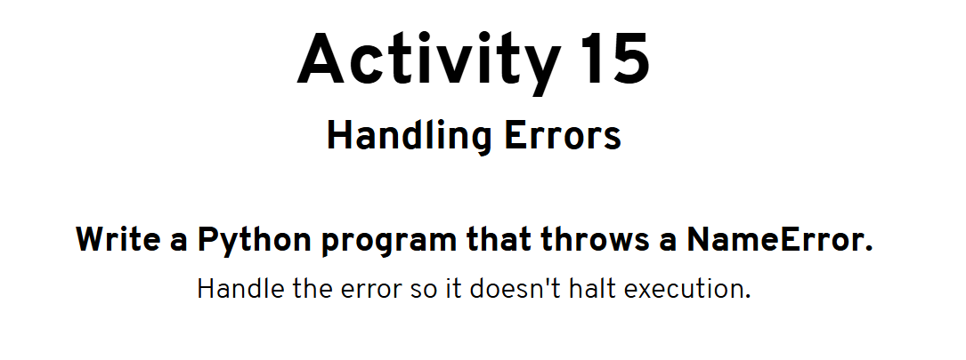

Program:

try:

print(x)

except NameError:

print("x hasn't been defined yet.")

Output:



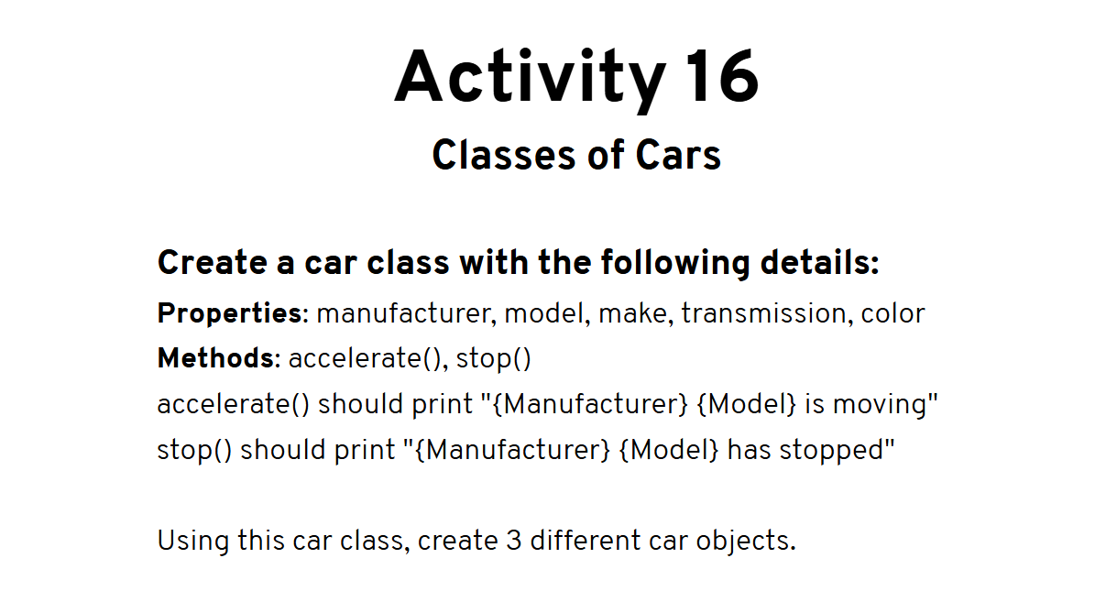

Program:

class Car:

'This class represents a car'

def __init__(self, manufacturer, model, make, transmission, color):

self.manufacturer = manufacturer

self.model = model

self.make = make

self.transmission = transmission

self.color = color

def accelerate(self):

print(self.manufacturer + " " + self.model + " has started moving")

def stop(self):

print(self.manufacturer + " " + self.model + " has stopped moving")

car1 = Car("Toyota", "Corolla", "2015", "Manual", "White")

car2 = Car("Maruti", "800", "2013", "Manual", "Red")

car3 = Car("Suzuki", "Swift", "2017", "Automatic", "Black")

car1.accelerate()

car1.stop()

Output:

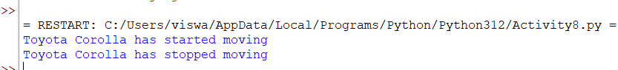

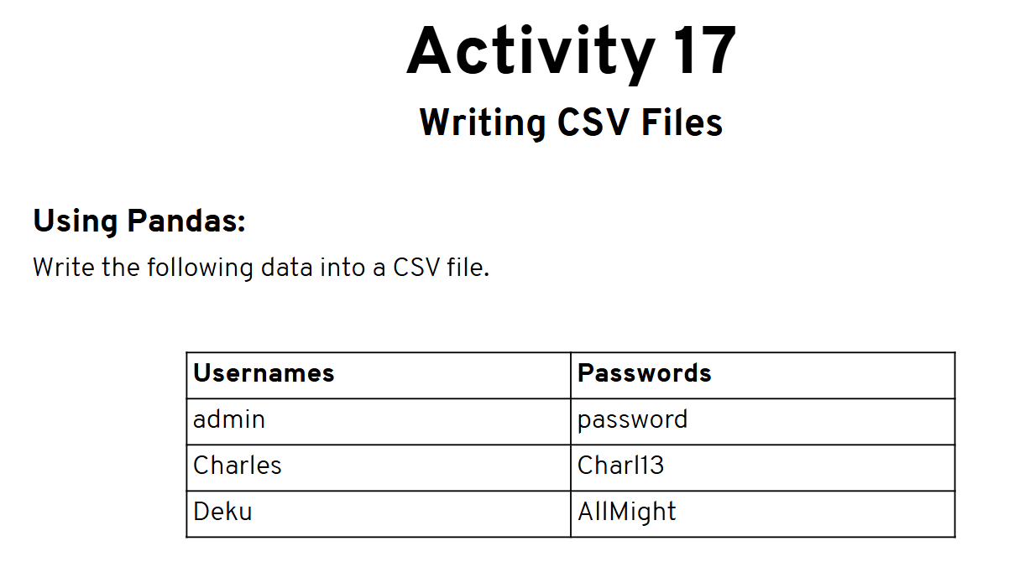

**Program:**

import pandas

data = {

"Usernames": ["admin", "Charles", "Deku"],

"Passwords": ["password", "Charl13", "AllMight"]

}

dataframe = pandas.DataFrame(data)

print(dataframe)

dataframe.to_csv("sample.csv", index=False)

**Output:**

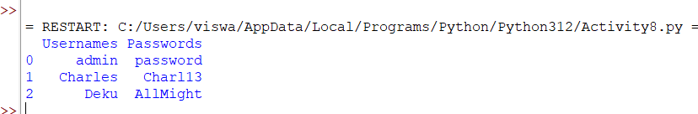

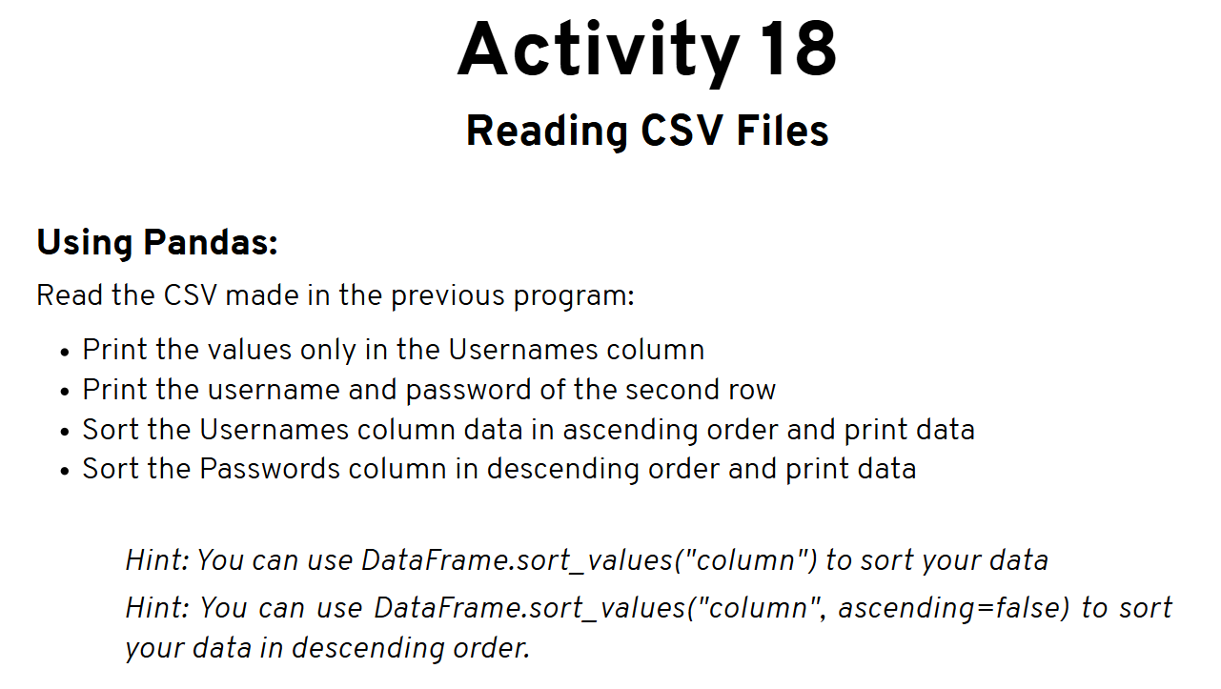

**Program:**

import pandas

dataframe = pandas.read_csv("sample.csv")

print("Full Data: ")

print(dataframe)

print("===============")

print("Usernames:")

print(dataframe["Usernames"])

print("===============")

print("Username: ", dataframe["Usernames"][1], " | ", "Password: ", dataframe["Passwords"][1])

print("====================================")

print("Data sorted in ascending Usernames:")

print(dataframe.sort_values('Usernames'))

print("====================================")

print("Data sorted in descending Passwords:")

print(dataframe.sort_values('Passwords', ascending=False))

**Output:**

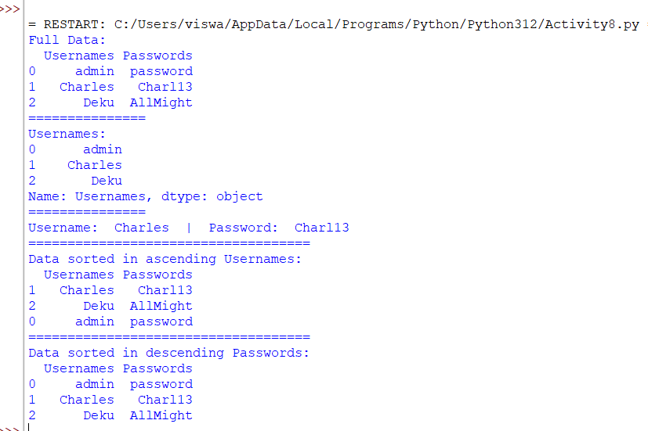

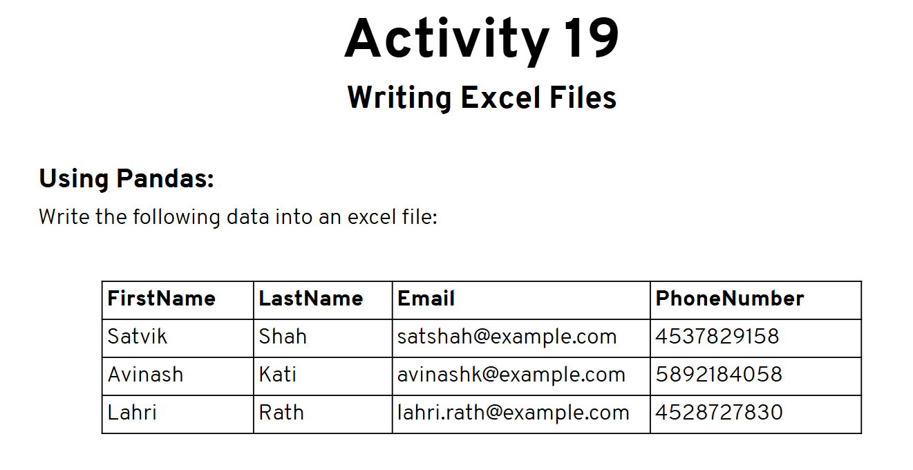

**Program:**

import pandas

from pandas import ExcelWriter

data = {

'FirstName':["Satvik", "Avinash", "Lahri"],

'LastName':["Shah", "Kati", "Rath"],

'Email':["satshah@example.com", "avinashK@example.com", "lahri.rath@example.com"],

'PhoneNumber':["4537829158", "4892184058", "4528727830"]

}

dataframe = pandas.DataFrame(data)

print(dataframe)

writer = ExcelWriter('sample.xlsx')

dataframe.to_excel(writer, 'Sheet1', index = False)

writer.close()

Output: